Government of the Republic of the Union of Myanmar


THE DEPARTMENT OF RURAL DEVELOPMENT
Ministry of Agriculture, Livestock and Irrigation

National Community Driven Development Project
World Bank Grant No: H814MM

INVITATION TO QUOTE (ITQ)
for Procurement of Goods:
G - 81 – Printed Items for Grievance Handling

Issued Date: April 01, 2017

INVITATION TO QUOTE (ITQ)

THE DEPARTMENT OF RURAL DEVELOPMENT

WISHES TO PURCHASE:

G - 81 – Printed Items for Grievance Handling

The Department of Rural Development has received funding from the International Development Association (IDA) towards the cost of the National Community Driven Development Project, World Bank Grant No: H814MM, and intends to apply part of the proceeds toward payments under the Purchase Order / Contract for : Printed Items for Grievance Handling.

Quotation competition will be conducted through Shopping Procedures as specified in the World Bank’s Guidelines: Procurement of Goods, Works and Non-Consulting Services under IBRD Loans and IDA Credits & Grants by World Bank Borrowers, dated January 2011 and is open to all eligible Suppliers as defined in the Procurement Guidelines.

Reference No. | Lot N° | Item N° | Description | Unit | Quantity
G 81 | 1 | 1 | Grievance Pamphlets | Unit | 96,000
 | 2 | 1 | Manual booklet for focal persons | Book | 52,000
 | 3 | 1 | Grievance Letter/ Envelop | Unit | 182,000
Supply to |  |  | Department of Rural Development, Office No.(14),Nay Pyi Taw, fifteen (15) Regional offices and forty seven (47) Project Township Offices spread over the National Territory.

- The goods are required to be supplied by URGENTLY, and at the latest within sixty (60) days from the date of the contract.

- Interested qualified eligible suppliers are invited to obtain a copy of the bidding documents free-of-charge from the address given below by submitting a written application. Except for the submission of a written application, there shall be no other conditions for obtaining the bidding documents. Bidding documents will be sent by e-mail only.

- To be considered eligible and qualified a firm or individual must:

- Have completed within the last 3 years at least one contract of a similar nature of at least 50% of the value of the bid or have sold similar goods of at least twice the volume /quantity required.
- Have the necessary production and packing installations to ensure the printing work, packing and timely dispatch toward the sixty three (63) destinations all over Myanmar
- Have one or more shops of offices in Myanmar to provide after sales services
- Demonstrate that they are paying taxes to the Government.
- Not be under any notice of suspension or debarment issued by the Government, or the World Bank.

- Bids must be delivered to the address given below at or before Tuesday 25 April 2017 at 10 am Myanmar time. Late bids will be rejected. Bids will be opened in public immediately thereafter at the address given below in the presence of the Bidders' representatives and the project's beneficiaries from the concerned local community who choose to attend shall be allowed to be present in person.

- The Purchaser shall award the Contract to the Bidder whose offer has been determined to be the lowest evaluated bid and is substantially responsive to the Bidding Documents, provided further that the Bidder is determined to be qualified to perform the Contract satisfactorily.

- All bids must be accompanied by a bid securing declaration as described in the bidding documents, any bid not accompanied by one will be rejected as non-compliant

- The address where the document may be inspected and obtained is:

NCDD Project Secretariat, Department of Rural Development,
Ministry of Agriculture, Livestock and Irrigation, Office N° 14, Nay Pyi Taw.
The Procurement Officer concerned is Ms. Shang Hkawng Ja Gu
Telephone Number : (+95-67) 409071
Fax Number: (+95-67)409413
E-mail: unioncddprocurement@gmail.com

- In case of any difficulty in obtaining the bidding documents, interested parties may contact in writing:

Mr. U Kyaw Soe, Deputy Director General and Chairperson of the Procurement Committee
NCDD Project Secretariat, Department of Rural Development,
Ministry of Agriculture, Livestock and Irrigation,
Office N° 14, Nay Pyi Taw.
Telephone Number: (+95-67) 409071
Fax Number: (+95-67) 409413
E-mail: drdmyanmar@gmail.com

- The address for bid submission and bid opening is:
The Department of Rural Development, Office N° 14, Nay Pyi Taw.
The bid submission and opening ceremony will take place in the DRD conference room.
The Procurement Officer concerned is Ms. Shang Hkawng Ja Gu.
- The Government of the Republic of the Union of Myanmar and/or the World Bank will declare a firm ineligible either indefinitely or for a stated period of time to be awarded a contract financed by the Government of the Republic of the Union of Myanmar and/or the World Bank respectively, if it at any time determines that the firm has engaged in corrupt or fraudulent, coercive or collusive practices in competing for or in executing a contract. Please refer to Attachment 1 ‘The Bank’s Policy on Fraud and Corruption.
SECTION 1. INSTRUCTIONS TO BIDDERS

- Goods: The Department of Rural Development, as the Purchaser, invites bids for the supply of PC, laptops, printers and scanners as described in the Conditions of Contract(CC). The successful bidder will be expected to deliver the Goods within the time allowed under the Conditions of Contract.

- The Government of the Republic of the Union of Myanmar has received funding from the World Bank towards the cost of the National Community Driven Development Project. The Purchaser intends to apply a portion of the proceeds of the funding to eligible payments under the contract(s) for which these Bidding Documents are issued. No payment shall be made to persons or entities for any import of goods, if such payment or import is prohibited by a decision of the United Nation’s Security Council, taken under chapter VII of the Charter of the United Nations.

- Eligibility and Qualifications of the Bidder: Only bidders that meet the following criteria will be eligible for an award of contract:

  - Have completed within the last 3 years at least one contract of a similar nature of at least 50% of the value of the bid or have sold similar goods of at least twice the volume/quantity required.
  - Have necessary production and packing installations to ensure the printing work, packing and timely dispatch of the goods toward the sixty three (63) destinations all over Myanmar
  - Have one or more shops or offices in Myanmar to provide after sales services
  - Demonstrate that they are paying taxes to the Government.
  - Not be under any notice of suspension or debarment issued by the Government, or the World Bank.

The bidder shall be required to provide documentary evidence with its bid to demonstrate that it meets the above requirements.

- Fraud and Corruption. The World Bank requires that Borrowers or Recipients (including beneficiaries of the funds), as well as bidders, suppliers, contractors and consultants observe the highest standard of ethics during the procurement and execution of contracts. In pursuance of this policy, both the Government of the Republic of the Union of Myanmar and the World Bank as details in Attachment 1 ‘World Bank Policy – Corruption and Fraudulent Practices’.

- Contents of Bid Documents: The set of Bid documents comprises the documents listed below:
Invitation to Quote
SECTION 1. INSTRUCTIONS TO BIDDERS
SECTION 2. CONDITIONS OF CONTRACT FOR THE SUPPLY OF GOODS
SECTION 3. PRICE AND DELIVERY SCHEDULE
SECTION 4. TECHNICAL SPECIFICATIONS AND DRAWINGS
SECTION 5. FORM OF BID
SECTION 6. FORM OF CONTRACT AGREEMENT
SECTION 7. BID AND PERFORMANCE SECURING DECLARATION

- Documents and Reference Samples comprising the Bid:
The Bid submitted by the Bidder shall comprise the following documents:
Form of Bid
Price and Delivery Schedule
Statement of Compliance with the Technical Specifications
Bid and Performance Securing Declaration
Bidder’s description of printing and packaging installations and declaration of having the necessary capacity in order to ensure the printing, packing and dispatch of the goods toward the sixty three (63) destinations all over Myanmar
Copy of the Bidder’s valid Trade License (TL)
Copy of the Original Receipt of Taxes paid bearing the stamp of the Competent Authorities
Reference documents confirming the qualification and eligibility of the Bidder
The Bid submitted by the Bidder shall comprise the following reference samples:
Bids for Lot 1: A sample Pamphlet for the size indicated in the technical specifications
Bids for Lot 2: A sample Booklet
Bids for Lot 3: A letter /Envelope
All samples will be labeled with the name of the Bidder and “ITQ 81”. Samples will not be returned and will remain part of the Bid. The sample delivered for the successful bid(s) will serve as reference sample for the assessment of conformity of the goods at the time of delivery and intermediate inspection.

- Bid and Evaluation Criteria: The Bidder must bid for all the required items on lot basis, and the evaluation of bids shall also be lot-wise. The Purchaser shall award the Contract to the Bidder whose bid has been determined to be the lowest evaluated bid and is substantially responsive to the Bidding Documents, provided further that the Bidder is determined to be qualified to perform the Contract satisfactorily.

- Bid Prices: Prices should be quoted in Myanmar Kyat (MMK)for the Goods delivered at the final destination (Project Site) specified in the Price and Delivery Schedule, inclusive of all costs such as customs duties, sales and other taxes paid or payable if the contract is awarded, transportation, insurance, and other local charges required for conveying the goods to the final destination. Prices shall remain fixed and not subject to price adjustment during the period of performance of the contract.

- Validity of Bid. The bid shall remain valid for the period of sixty (60) calendar days counted from the deadline for submission of bids specified in Paragraph 12 of these Instructions. The Purchaser may request Bidders to extend the period of validity for a specified additional period. The Purchaser’s request and the Bidder’s responses shall be made in writing or by fax or by email. A Bidder may refuse the request for extension of bid validity in which case he may withdraw his Bid without any penalty. A Bidder agreeing to the request will not be required or permitted to otherwise modify its Bid.

- Language of the Bid: All documents relating to the Bid and contract shall be in English language.

- Preparation and Sealing of Bid: The Bidder shall prepare one original of the documents comprising the Bid as described in Paragraph (6) of these Instructions, and clearly marked “Original”. In addition, the Bidder shall also submit one copy which shall be clearly marked as “COPY” . In the event of discrepancy between them the original shall prevail. The original and the copy of the Bid shall be signed by a person or persons duly authorized to sign on behalf of the Bidder. All the pages of the Bid where entries or amendments or corrections have been made shall be initialed by the person or persons signing the Bid. The Bidder shall seal the original and the copy of the Bid in two inner envelopes and one outer envelope, duly marking the inner envelopes as “ORIGINAL” and “COPY”. The inner and the outer envelopes shall be addressed to the Purchaser at the address provided in paragraph 8 the Invitation to Bid and shall provide a warning “DO NOT OPEN BEFORE THE SPECIFIED TIME AND DATE FOR BID OPENING” as defined in paragraph12 of these Instructions. The inner envelopes shall indicate the name and full address of the Bidder. If the outer envelope is not sealed and marked as above, the Purchaser will assume no responsibility for the misplacement or premature opening of the Bid.

- Place and Deadline for Submission of Bids: The Bids shall be delivered to the Purchaser NO LATER than Tuesday 25 April 2017 at 10 am Myanmar time at the address given in paragraph 8 of the Invitation to Quote. Any Bid received by the Purchaser after the deadline prescribed in this clause will be returned unopened to the Bidder.

- Bid and Performance Securing Declaration: The Bid and Performance Securing Declaration should be in accordance with the form included in SECTION 7 BID AND PERFORMANCE SECURING DECLARATION and shall be valid for the warranty period described in paragraph 7 of the Conditions of Contract. Any Bid not accompanied by a Bid and Performance Securing Declaration will be rejected by the Purchaser as non-responsive. The execution of a bid securing declaration will result in the Bidder being held ineligible for all contracts let by the Government irrespective of the funding source for a period of two years from the date of the Purchaser’s execution of this Declaration unless, at a Bidder’s option, the Bidder pays to the Purchaser an administrative penalty of two percent (2%) of the total bid amount to the Purchaser. The Bid Securing and Performance Declaration will be executed:

- If a Bidder withdraws its bid during the period of bid validity specified by the Bidder on the Bid Form or
- If the Bidder does not accept the correction of its Bid Price pursuant to paragraph 17 of these Instructions.
- If the successful Bidder fails within the specified time to sign the Contract:
- If the successful bidder, once contracted commits a fundamental breach of contract leading to the Purchaser’s termination of the contract for reasons of the successful bidder’s default.

- Modification and Withdrawal of Bids: No Bids shall be modified after the deadline for submission of Bids specified above in paragraph 12 of these Instructions. Withdrawal of a Bid between the deadline for submission of Bids and the expiration of the validity of the Bids as specified in paragraph 9 of these Instructions above may result in the execution of the Bid and Performance Securing Declaration.

- Opening of Bids: The Purchaser will open the Bids in the presence of the bidders’ representatives and representatives of the project’s beneficiaries from the local community who choose to attend, at the time, date, and in the place specified in paragraph12 of these Instructions. The bidders’ names, the Bid prices, the total amount of each Bid and any discounts, Bid modifications and withdrawals, the presence or absence of Bid Security or Bid Securing Declaration, and such other details as the Purchaser may consider appropriate, will be read out and recorded at the opening. The minutes shall be signed in original by all those present at the bid opening. Immediately upon conclusion of the bid opening proceedings, copies of the minutes shall be provided to the bidders and community representatives present at the bid opening. In addition, a copy of the minutes shall promptly be posted at a prominent and freely accessible location outside the office of the Purchaser, and also sent to all those who obtained the bidding documents but were not present at the bid opening.

- Process to be Confidential: All information relating to the examination, clarification, evaluation and comparison of bids for the contract award shall not be disclosed until the award to the successful Bidder has been announced.

- Evaluation and Comparison of Bids: The Purchaser will award the Contract to the Bidder whose Bid has been determined to be substantially responsive and compliant to the technical specification and standards therein and who has offered the lowest evaluated Bid and has been determined to be qualified to perform the Contract satisfactorily. In evaluating the Bids, the Purchaser will determine for each Bid the evaluated Bid Price by making any correction for any arithmetic errors as follows:

- Where there is a discrepancy between amounts in figures and in words, the amount in words will govern;
- Where is a discrepancy between the unit rate and the line item total resulting from multiplying the unit rate by the quantity, the unit rate as quoted will govern;

If a Bidder refuses to accept the correction, his Bid will be rejected and Bid and Performance Securing Declaration executed.

- Purchaser’s Right to Accept Any Bids and to Reject any or all Bids: The Purchaser reserves the right to accept or reject any bid, and to cancel the process of competition and reject all bids, at any time prior to the award of the Contract, without thereby incurring any liability to the affected Bidder(s).

19. Purchaser’s Right to Vary Quantities at Time of Award: At the time the Contract is awarded, the Purchaser reserves the right to increase or decrease the quantity of Goods and Related Services originally specified in Section 3, Price and Delivery Schedule, provided this does not exceed fifteen (15) percent, and without any change in the unit prices or other terms and conditions of the bid and the Bidding Documents.

- Notification of Award and Signing of Contract: The Bidder whose Bid has been accepted will be notified of the award by the Purchaser prior to the expiration of the validity period of the Bid, by registered letter. The written notification of award will constitute the formation of the Contract.

- Debriefing. After the award of contract has been announced an unsuccessful Bidder has the right to request a debriefing to ascertain why its bid was unsuccessful and the Purchaser the obligation to provide it. No commercial confidences will breached and no detailed information concerning other bids will be disclosed other than the information already read out at bid opening and the reasons for any and all bids rejection.

- Complaints. A complaint may be made by any party at any stage of the procurement process. No complaint will be responded to during the evaluation period. Complaints received during the evaluation period will be reviewed by the Purchaser and a response issued only after the evaluation is completed. Complaints shall be addressed to the Project Director Mr. U Kyaw Soe, NCDD Project Secretariat, Department of Rural Development, Office N° 14, Nay Pyi Taw. Telephone (95-67)409361. Fax (95-67)409413. The Project Director will investigate the grounds for the complaint and, with the exception of those complaints received during the evaluation period as described above, respond to in writing within 14 calendar days of receiving the complaint. In the event that the response from the Project Director does not satisfy the bidder or there is no response to the complaint it should be referred to Mr. U Khant Zaw, Director General, NCDD Project Secretariat, Department of Rural Development, Ministry of Agriculture, Livestock and Irrigation, Office N° 14, Nay Pyi Taw. In such case, a copy of the complaint should also be sent to the World Bank,57 Pyay Road, 6,5 Mile, Hlaing Township, Yangon, Mr. Nikolas Myint, Telephone (95-1)654824 and Fax (95-1)654825.

- Publication of Award. The Purchaser shall notify in writing all participating bidders of the results of the bid evaluation promptly after the contract has been awarded, and publish on the Ministry website, promptly at the end of each quarter, a notice informing the general public of the availability of contract awards summary and contract registers in the office of the Purchaser.

SECTION2. CONDITIONS OF CONTRACT FOR THE SUPPLY OF GOODS

Article 1 General Provisions

- The Supplier confirms that he has examined, read and understood fully all the Contract Documents, being:

- The Form of Contract,
- the Conditions of Contract,
- the Special Conditions of Contract
- the Technical Specifications
- the Form of Bid submitted by the Supplier,
- the Price and Delivery Schedule,
- the Purchaser’s Notification of Award together form the Contract

- The Contract shall be amended only by written agreement between the Purchaser and the Supplier.

- The law applicable to the Contract shall be that of the Republic of the Union of Myanmar. Every effort shall be made to resolve disputes amicably and without recourse or referral to third parties. Any dispute that cannot be resolved amicably shall be referred by either Party to the Chamber of Commerce for adjudication in accordance with the under the Rules of Conciliation and Arbitration of the International Chamber of Commerce.

Article2 Purchaser’s and Supplier’s obligations

- The Purchaser and the Contractor now agree as follows:

- The Contract Price is _____________________________________ (insert amount in words and figures).This amount is for the full delivery of the goods listed in the Price and Delivery Schedule.

- The Supplier shall supply
___________________________________________________________ (insert description of the goods) on or before the delivery date and at the final destination (Project Site), as stipulated in the Price and Delivery Schedule, and conforming to the standards as stipulated in the Technical Specifications. The Supplier shall be responsible for fully insuring the Goods against loss or damage from “warehouse to warehouse” (final destination) on “All Risk basis”.

- The Purchaser has the right to reduce the payment to the Supplier by 0.1% of the total price of the Contract for each day of delay beyond the delivery date shown in the Price and Delivery Schedule. The reduction is up to a maximum of 10%, then after the Purchaser may terminate the contract.

- If war or natural disaster makes completion of the contract impossible, the Supplier may ask the Purchaser to release him from the Contract.

- The Supplier guarantees that all goods supplied will be new and unused and carry a warranty of minimum 1 years warranty on hardware and onsite service warranty starting from the date of acceptance of the goods by the Purchaser. Throughout this period the Supplier agrees to make good, at its own expense, any defect that appears during that time due to quality of materials or workmanship.

Article3 Payment Provisions

- Payments will be made according to the schedule and terms and conditions set out below:

Steps of Payment | Amount | Payment Conditions
Payment No 1 | 90% of the Contract Price | Upon receipt of the Goods in the Sixty three (63) project sites
Payment No 2 | 10% of the Contract Price | Upon inspection and acceptance  of the Goods

- Processing of payments will be as follows:

- 90% of the Contract Price. The Purchaser will issue a receipt for the goods upon delivery to the Project Site, the Supplier shall submit its commercial invoice with the original receipt attached and three Copies of both, signed by the supplier as true and correct copies. The Purchaser will effect payment within 30 days of submission;

- 10% of the Contract Price. Within 7 days of receiving the goods the Purchaser will undertake any inspections and tests that it deems necessary. Provided that the goods pass any such inspection or tests the Purchaser will issue an acceptance certificate to the Supplier. The Supplier shall submit its commercial invoice with the original acceptance certificate attached and three copies of both, signed by the supplier as true and correct copies. The Purchaser will effect payment within 30 days of submission.

- In the event that after the expiry of 7 days after the delivery of the goods, the Purchaser does not provide the Supplier with an acceptance certificate (or issue instructions to repair or replace any defective goods), the Supplier shall submit its invoice in three copies signed as true and correct, for the remaining 10% of the value of the goods delivered and the Purchaser will effect payment within 30 days of submission.

- Payment shall be made in Myanmar Kyat (MMK) in the proportion specified below.

- If any payment is delayed for more than1 calendar month after the due date for Payment, the Purchaser will pay interest to the Supplier at the rate of 2% of the amount of the payment for the first month and for each subsequent full calendar month during which payments are delayed.

- If the Contract is cancelled because of the fault of the Supplier, the Purchaser has the right to obtain the goods from another source. The Supplier shall be liable for any purchase costs paid in excess of this Contract’s value.

Article4 Fraud and Corruption

The World Bank requires that Borrowers or Recipients (including beneficiaries of the funds), as well as bidders, suppliers, contractors and consultants observe the highest standard of ethics during the procurement and execution of contracts according to the Attachment 1 ‘World Bank Policy – Corruption and Fraudulent Practices’

Article 5 Special Conditions

The Supplier will timely inform the Department of Rural Development (DRD) that the goods are ready for dispatch to the sixty three (63) project sites in the Country. The DRD has the intention to perform an intermediate physical inspection of the goods prior to their dispatch to the project sites. This physical inspection will be organized in order to assess the conformity of the goods at a moment where corrective measures can still be taken by the Manufacturer in case of non-conformity or production errors. This intermediate physical inspection does not substitute the final inspection and acceptance of the goods at the different townships and consequently, will not allow the Supplier to issue and present an invoice.

In witness of what has been agreed above, the signatures of the authorized representatives of the two Parties are affixed below on the date shown.
For the Supplier: | Stamp
Company/ Supplier Name:

Signature:

Authorized person name:
Designation

Date

For the Purchaser: | Stamp
The Department of Rural Development

Signature:

Authorized person name:
Designation

Date

Attachment 1
World Bank Policy - Corrupt and Fraudulent Practices
Guidelines for Procurement of Goods, Works, and Non-Consulting Services under IBRD Loans and IDA Credits & Grants by World Bank Borrowers, dated January 2011.
“Fraud and Corruption:
1.16 It is the Bank’s policy to require that Borrowers (including beneficiaries of Bank loans), bidders, suppliers, contractors and their agents (whether declared or not), sub-contractors, sub-consultants, service providers or suppliers, and any personnel thereof, observe the highest standard of ethics during the procurement and execution of Bank-financed contracts. In pursuance of this policy, the Bank:
(a) defines, for the purposes of this provision, the terms set forth below as follows:
(i) “corrupt practice” is the offering, giving, receiving, or soliciting, directly or indirectly, of anything of value to influence improperly the actions of another party;;
(ii) “fraudulent practice” is any act or omission, including a misrepresentation, that knowingly or recklessly misleads, or attempts to mislead, a party to obtain a financial or other benefit or to avoid an obligation;
(iii) “collusive practice” is an arrangement between two or more parties designed to achieve an improper purpose, including to influence improperly the actions of another party;
(iv) “coercive practice” is impairing or harming, or threatening to impair or harm, directly or indirectly, any party or the property of the party to influence improperly the actions of a party;
(v) "obstructive practice" is:
(aa) deliberately destroying, falsifying, altering, or concealing of evidence material to the investigation or making false statements to investigators in order to materially impede a Bank investigation into allegations of a corrupt, fraudulent, coercive or collusive practice; and/or threatening, harassing or intimidating any party to prevent it from disclosing its knowledge of matters relevant to the investigation or from pursuing the investigation, or
(bb) acts intended to materially impede the exercise of the Bank’s inspection and audit rights provided for under paragraph 1.16(e) below.
(b) will reject a proposal for award if it determines that the bidder recommended for award, or any of its personnel, or its agents, or its sub-consultants, sub-contractors, service providers, suppliers and/or their employees, has, directly or indirectly, engaged in corrupt, fraudulent, collusive, coercive, or obstructive practices in competing for the contract in question;
(c) will declare misprocurement and cancel the portion of the loan allocated to a contract if it determines at any time that representatives of the Borrower or of a recipient of any part of the proceeds of the loan engaged in corrupt, fraudulent, collusive, coercive, or obstructive practices during the procurement or the implementation of the contract in question, without the Borrower having taken timely and appropriate action satisfactory to the Bank to address such practices when they occur, including by failing to inform the Bank in a timely manner at the time they knew of the practices;
(d) will sanction a firm or individual, at any time, in accordance with the prevailing Bank’s sanctions procedures, including by publicly declaring such firm or individual ineligible, either indefinitely or for a stated period of time: (i) to be awarded a Bank-financed contract; and (ii) to be a nominated;
(e) will require that a clause be included in bidding documents and in contracts financed by a Bank loan, requiring bidders, suppliers and contractors, and their sub-contractors, agents, personnel, consultants, service providers, or suppliers, to permit the Bank to inspect all accounts, records, and other documents relating to the submission of bids and contract performance, and to have them audited by auditors appointed by the Bank.”

SECTION 3. PRICE AND DELIVERY SCHEDULE
Lot | Item  N° | Description of Goods | Quantity | Physical  unit | Delivery Final Destination (Project Site) | Delivery  Date | Unit price per item  delivered at Final Destination  (Project Site)1 | Total price per item  Delivered at Final Destination  (Project Site)1
1 | 1 | Grievance Pamphlets | 96,000 | Pamphlets | DRD, Nay Pyi Taw, 15 Regional Offices and 47 project sites in Myanmar | 60 days | [to be filled by bidder] | [to be filled by bidder]
Total Lot N° 1 |  |  |  |  |  |  |  | [to be filled by bidder]
2 | 1 | Manual booklet for focal Persons | 52,000 | Booklets | DRD, Nay Pyi Taw, 15 Regional Offices and 47 project sites in Myanmar | 60 days | [to be filled by bidder] | [to be filled by bidder]
Total Lot N° 2
3 | 1 | Grievance Letter/ Envelope | 182,000 | Envelopes | DRD, Nay Pyi Taw, 15 Regional Offices and 47 project sites in Myanmar | 60 days | [to be filled by bidder] | [to be filled by bidder]
Total Lot N° 3 |  |  |  |  |  |  |  | [to be filled by bidder]
Total Bid Price (= Sum of the total prices of the Lots the Bidder wishes to bid for) |  |  |  |  |  |  |  | [to be filled by bidder]

Total Bid Price : _________________________________________________MMK
In words: _________________________________________________________________
_______________________________________________________________MMK
Authorized Signature of the Bidder :

______________________________________
- Currency to be used is MMK (Myanmar Kyat). The prices all include all customs duties and sales and other taxes already paid or payable, transportation, insurances,
and any other local charges for delivery of the goods up to final destination.

Stamp

Note: In case of discrepancy between unit price and total, the unit price shall prevail.

Distribution list/Delivery Details (project sites) of LOT 1 : GRIEVANCE PAMPHLETS
Distribution List for Grievance Pamphlets
No | State/ Region | Township | Total Grievance Pamphlet
1 | Kachin | Myitkyina | 10
2 |  | Moegaung | 900
 | Subtotal Kachin |  | 910
3 | Kayah | Loikaw | 10
4 |  | Loikaw | 1,330
5 |  | Shartaw | 300
6 |  | Hpasawng | 700
7 |  | Bawlakhe | 270
8 |  | Mese | 220
9 |  | Hpruso | 1,260
10 |  | Demoso | 1,870
 | Subtotal Kayah |  | 5,960
11 | Kayin | Hpa- An | 10
12 |  | Kyain Seikgyi | 3,850
 | Subtotal Kayin |  | 3,860
13 | Chin | Hakha | 10
14 |  | Kanpetlet | 1,330
15 |  | Paletwa | 1,600
16 |  | Madupi | 4,000
 | Subtotal Chin |  | 6,940
17 | Sagaing | Monywa | 10
18 |  | Pinlebu | 2,760
19 |  | Myaung | 910
20 |  | Banmauk | 2,290
 | Subtotal Sagaing |  | 5,970
21 | Tanintharyi | Dawei | 10
22 |  | Kyunsu | 1,730
23 |  | Tanintharyi | 1,860
 | Subtotal of Tanintharyi |  | 3,600
24 | Bago | Bago | 10
25 |  | Monyo | 2,280
26 |  | Kyaukkyi | 1,470
27 |  | Padaung | 2,180
 | Subtotal of Bago |  | 38,950
28 | Magway | Magway | 10
29 |  | Sidoktaya | 1,250
30 |  | Mindon | 1,890
31 |  | Saw | 1,250
32 |  | Tilin | 1,030
33 |  | Pauk | 2,670
 | Subtotal of Magway |  | 8,100
34 | Mandalay | Mandalay | 10
35 |  | Ngazun | 1,680
36 |  | Naung U | 2,300
37 |  | Pyawbwe | 3,270
38 |  | Natogyi | 1,980
39 |  | Yamethin | 2,560
 | Subtotal Mandalay |  | 11800
40 | Mon | Mawlamyine | 10
41 |  | Chaungzon | 880
42 |  | Bilin | 2,260
43 |  | Paung | 1,650
 | Subtotal of Mon |  | 4,800
44 | Rakhine | Sittway | 10
45 |  | Ann | 2,520
 | Subtotal Rakhine |  | 2,530
46 | Yangon | Yangon | 10
47 |  | Htantabin | 2,580
48 |  | Kawmhu | 1,460
49 |  | Kungyangon | 1,450
50 |  | Kyauktan | 880
 | Subtotal of Yangon |  | 6,370
51 | Shan | Taunggyi | 10
52 |  | Namhsan | 1,330
53 |  | Hsihseng | 3,320
 | Subtotal of Shan |  | 4,660
54 | Ayeyarwaddy | Pathein | 10
55 |  | Lemyethnar | 3,120
56 |  | Thabaung | 3,940
57 |  | Kyangin | 2,550
58 |  | Ngaputaw | 4,110
 | Subtotal of Ayeyarwaddy |  | 14,130
59 | Naypyitaw | Naypyitaw | 10
60 |  | Tatkon | 1,880
61 |  | Lewe | 2,610
62 |  | Pyinmana | 1,400
 | Subtotal of Nay Pyi Taw |  | 6,200
 | Total for State/Region |  | 91780
63 | Union | Union level | 4,220
Grand Total |  |  | 96,000

- Distribution List/Delivery Details (project sites) of LOT 2: MANUAL BOOKLET FOR FOCALS

Distribution List for Manual Booklets for Focals
No | State/ Region | Township | Total Manual Booklets for Focals
1 | Kachin | Myitkyina | 10
2 |  | Moegaung | 460
 | Subtotal Kachin |  | 470
3 | Kayah | Loikaw | 10
4 |  | Loikaw | 675
5 |  | Shartaw | 160
6 |  | Hpasawng | 360
7 |  | Bawlakhe | 145
8 |  | Mese | 120
9 |  | Hpruso | 640
10 |  | Demoso | 945
 | Subtotal Kayah |  | 3,055
11 | Kayin | Hpa- An | 10
12 |  | Kyain Seikgyi | 1,935
 | Subtotal Kayin |  | 1,945
13 | Chin | Hakha | 10
14 |  | Kanpetlet | 675
15 |  | Paletwa | 810
16 |  | Madupi | 2,010
 | Subtotal Chin |  | 3,505
17 | Sagaing | Monywa | 10
18 |  | Pinlebu | 1,390
19 |  | Myaung | 465
20 |  | Banmauk | 1,155
 | Subtotal Sagaing |  | 3,020
21 | Tanintharyi | Dawei | 10
22 |  | Kyunsu | 875
23 |  | Tanintharyi | 940
 | Subtotal of Tanintharyi |  | 1,825
24 | Bago | Bago | 10
25 |  | Monyo | 1,150
26 |  | Kyaukkyi | 745
27 |  | Padaung | 1,100
 | Subtotal of Bago |  | 19,695
28 | Magway | Magway | 10
29 |  | Sidoktaya | 635
30 |  | Mindon | 955
31 |  | Saw | 1,210
32 |  | Tilin | 990
33 |  | Pauk | 1,345
 | Subtotal of Magway |  | 5,145
34 | Mandalay | Mandalay | 10
35 |  | Ngazun | 850
36 |  | Naung U | 1,160
37 |  | Pyawbwe | 1,645
38 |  | Natogyi | 1,000
39 |  | Yamethin | 1,290
 | Subtotal Mandalay |  | 5955
40 | Mon | Mawlamyine | 10
41 |  | Chaungzon | 450
42 |  | Bilin | 1,140
43 |  | Paung | 835
 | Subtotal of Mon |  | 2,435
44 | Rakhine | Sittway | 10
45 |  | Ann | 1,270
 | Subtotal Rakhine |  | 1,280
46 | Yangon | Yangon | 10
47 |  | Htantabin | 1,300
48 |  | Kawmhu | 740
49 |  | Kungyangon | 735
50 |  | Kyauktan | 450
 | Subtotal of Yangon |  | 3,225
51 | Shan | Taunggyi | 10
52 |  | Namhsan | 675
53 |  | Hsihseng | 1,670
 | Subtotal of Shan |  | 2,355
54 | Ayeyarwaddy | Pathein | 10
55 |  | Lemyethnar | 1,620
56 |  | Thabaung | 2,030
57 |  | Kyangin | 1,335
58 |  | Ngaputaw | 2,115
 | Subtotal of Ayeyarwaddy |  | 7,110
59 | Naypyitaw | Naypyitaw | 10
60 |  | Tatkon | 1,000
61 |  | Lewe | 1,365
62 |  | Pyinmana | 760
 | Subtotal of Nay Pyi Taw |  | 3,135
 | Total for State/Region |  | 46435
63 | Union | Union level | 5,565
Grand Total |  |  | 52000

3. Distribution List/Delivery Details (project sites) of LOT 3: GRIEVANCE LETTER/ ENVELOP

Distribution List for Grievance Letter/Envelope
No | State/ Region | Township | Total Grievance Letter/Envelope
1 | Kachin | Myitkyina | 50
2 |  | Moegaung | 1,700
 | Subtotal Kachin |  | 1,750
3 | Kayah | Loikaw | 50
4 |  | Loikaw | 2,560
5 |  | Shartaw | 500
6 |  | Hpasawng | 1,300
7 |  | Bawlakhe | 440
8 |  | Mese | 340
9 |  | Hpruso | 2,420
10 |  | Demoso | 3,640
 | Subtotal Kayah |  | 11,250
11 | Kayin | Hpa- An | 10
12 |  | Kyain Seikgyi | 7,600
 | Subtotal Kayin |  | 7,610
13 | Chin | Hakha | 10
14 |  | Kanpetlet | 2,560
15 |  | Paletwa | 3,100
16 |  | Madupi | 7,900
 | Subtotal Chin |  | 13,570
17 | Sagaing | Monywa | 10
18 |  | Pinlebu | 5,420
19 |  | Myaung | 1,720
20 |  | Banmauk | 4,480
 | Subtotal Sagaing |  | 11,630
21 | Tanintharyi | Dawei | 10
22 |  | Kyunsu | 3,360
23 |  | Tanintharyi | 3,620
 | Subtotal of Tanintharyi |  | 6,990
24 | Bago | Bago | 10
25 |  | Monyo | 4,460
26 |  | Kyaukkyi | 2,840
27 |  | Padaung | 4,260
 | Subtotal of Bago |  | 75,940
28 | Magway | Magway | 10
29 |  | Sidoktaya | 2,400
30 |  | Mindon | 3,680
31 |  | Saw | 1,250
32 |  | Tilin | 1,030
33 |  | Pauk | 5,240
 | Subtotal of Magway |  | 13,610
34 | Mandalay | Mandalay | 10
35 |  | Ngazun | 3,260
36 |  | Naung U | 4,500
37 |  | Pyawbwe | 6,440
38 |  | Natogyi | 3,860
39 |  | Yamethin | 5,020
 | Subtotal Mandalay |  | 23090
40 | Mon | Mawlamyine | 10
41 |  | Chaungzon | 1,660
42 |  | Bilin | 4,420
43 |  | Paung | 3,200
 | Subtotal of Mon |  | 9,330
44 | Rakhine | Sittway | 10
45 |  | Ann | 4,940
 | Subtotal Rakhine |  | 4,950
46 | Yangon | Yangon | 50
47 |  | Htantabin | 5,060
48 |  | Kawmhu | 2,820
49 |  | Kungyangon | 2,800
50 |  | Kyauktan | 1,660
 | Subtotal of Yangon |  | 12,340
51 | Shan | Taunggyi | 10
52 |  | Namhsan | 2,560
53 |  | Hsihseng | 6,540
 | Subtotal of Shan |  | 9,150
54 | Ayeyarwaddy | Pathein | 10
55 |  | Lemyethnar | 6,340
56 |  | Thabaung | 7,980
57 |  | Kyangin | 5,200
58 |  | Ngaputaw | 8,320
 | Subtotal of Ayeyarwaddy |  | 27,890
59 | Naypyitaw | Naypyitaw | 50
60 |  | Tatkon | 3,860
61 |  | Lewe | 5,320
62 |  | Pyinmana | 2,900
 | Subtotal of Naypyitaw |  | 12,130
63 | Union | Union level | 2,690
Grand Total |  |  | 182,000

SECTION 4.TECHNICAL SPECIFICATIONS AND DRAWINGS
Ref No. | Specification |  | Statement of Compliance
G 81 | All the specifications listed hereunder are minimum specifications.  All the specifications listed hereunder are for goods and materials that are new, unused, of the most recent or current models, and incorporate all recent improvements in design and materials unless provided otherwise in the Contract.  The Pamphlet, Guidebooks and Envelopes included here under as example may undergo minimal changes in terms of the final text and the illustrations to be printed. The final text and the illustrations will be confirmed by DRD at the latest at the time of the signature of the Contract Agreement. |  | Quotation must state here either “Comply” of “Not Comply” against each of the individual parameters of each Specification stating the corresponding performance parameter of the equipment offered. Statements of “Comply” or “Not Comply” must be supported by evidence in the quotation and cross-referenced to that evidence.  A statement that is not supported by evidence or is subsequently found to be contradicted by the evidence presented will render the quotation under evaluation liable for rejection. A statement either in the quotation statement of compliance or the supporting evidence that is found to be false either during evaluation or the execution of the contract may be regarded as fraudulent and render the quotation or supplier liable for prosecution.
LOT 1 | Grievance Pamphlets
1 | Type of paper | Art paper
2 | Paper Size | 15 inches x 8.5 inches
3 | Paper Thickness | One Mile
4 | Paper Weight | Wood free 128 gram
5 | Printing Color | as per the sample picture

Pictured example LOT 1 - Grievance Pamphlets
The candidate bidders can obtain a Grievance Pamphlet from the Department of Rural Development on simple request, but are kindly asked to come collect the sample Grievance Pamphlets after having made an appointment with the Procurement Officer in charge of this ITQ.
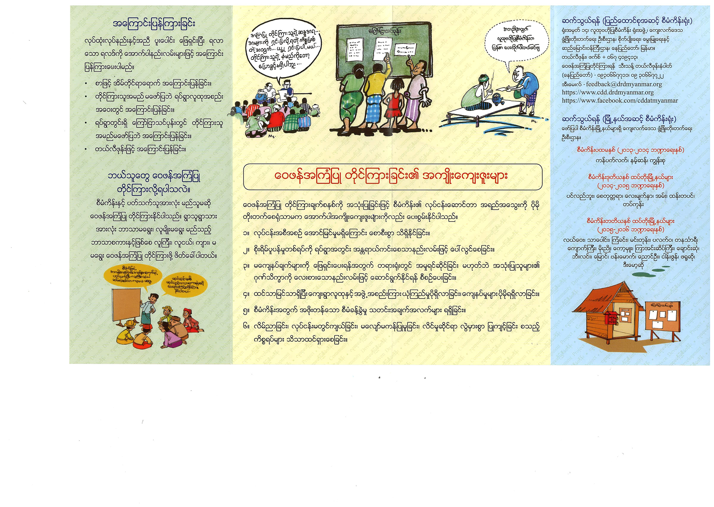
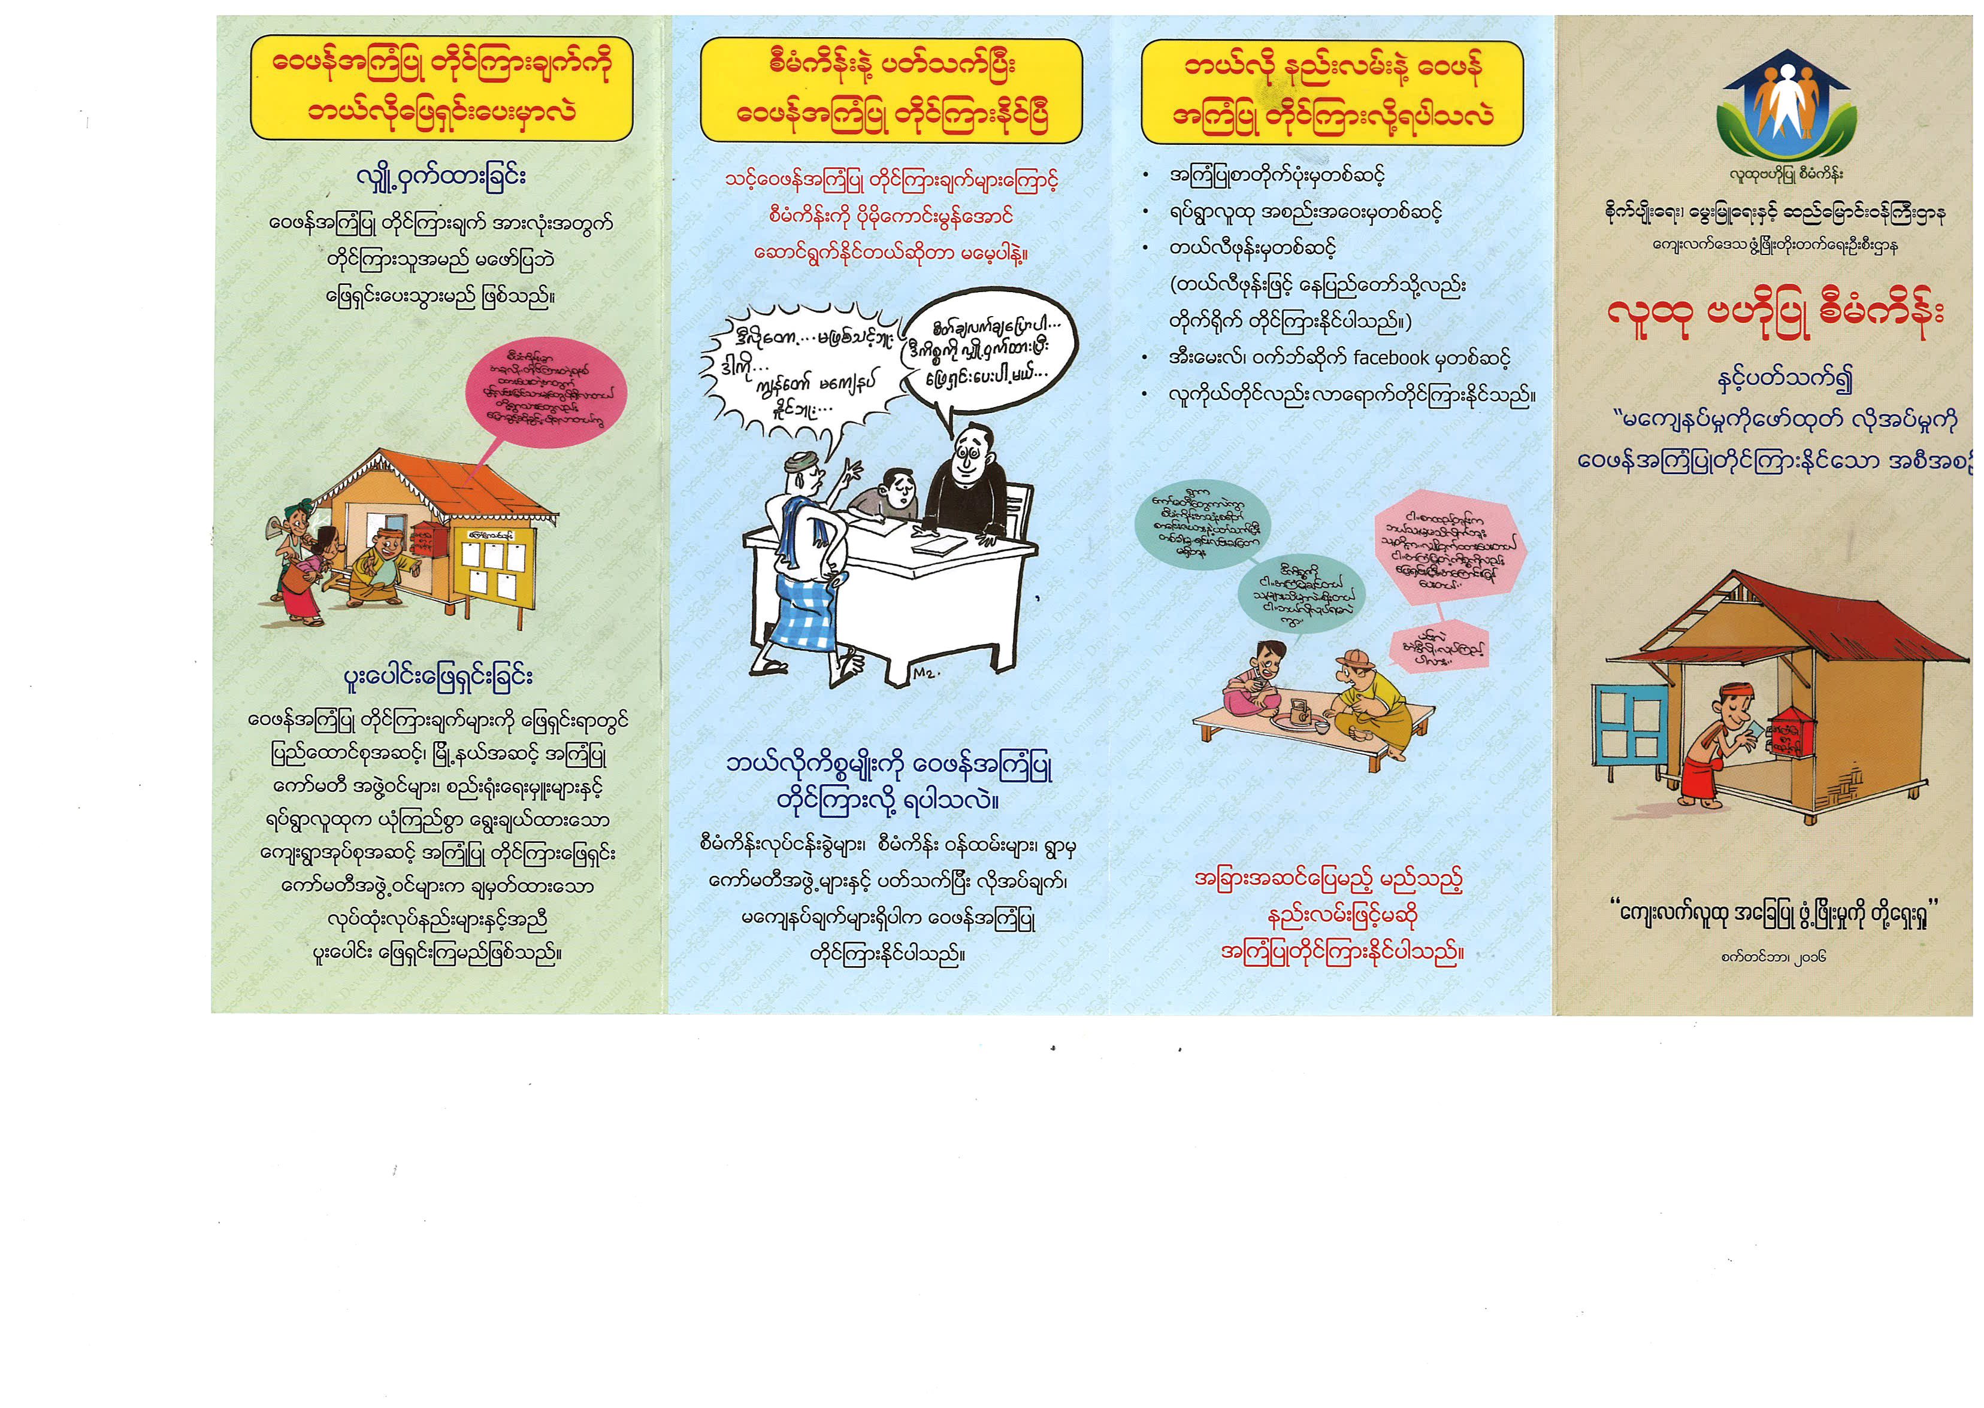

TECHNICAL SPECIFICATIONS AND DRAWINGS
Ref No. | Specification |  | Statement of Compliance
G 81 | All the specifications listed hereunder are minimum specifications.  All the specifications listed hereunder are for goods and materials that are new, unused, of the most recent or current models, and incorporate all recent improvements in design and materials unless provided otherwise in the Contract.  The Pamphlet, Guidebooks and Envelopes included here under as example may undergo minimal changes in terms of the final text and the illustrations to be printed. The final text and the illustrations will be confirmed by DRD at the latest at the time of the signature of the Contract Agreement. |  | Quotation must state here either “Comply” of “Not Comply” against each of the individual parameters of each Specification stating the corresponding performance parameter of the equipment offered. Statements of “Comply” or “Not Comply” must be supported by evidence in the quotation and cross-referenced to that evidence.  A statement that is not supported by evidence or is subsequently found to be contradicted by the evidence presented will render the quotation under evaluation liable for rejection. A statement either in the quotation statement of compliance or the supporting evidence that is found to be false either during evaluation or the execution of the contract may be regarded as fraudulent and render the quotation or supplier liable for prosecution.
LOT 2 | Manual Booklet For Focal persons
1 | Type of Paper | Art Paper
2 | Booklet Size | 5.7 inches by 8.2 inches
3 | Paper Thickness | One Mile
4 | Paper Weight | 100 gram/square meter
5 | No. of Pages | 32 pages
6 | Binding of Booklets | Stitched/Staples
7 | Color | As per the sample picture

Pictured example LOT 2 - Manual Booklet For Focal persons
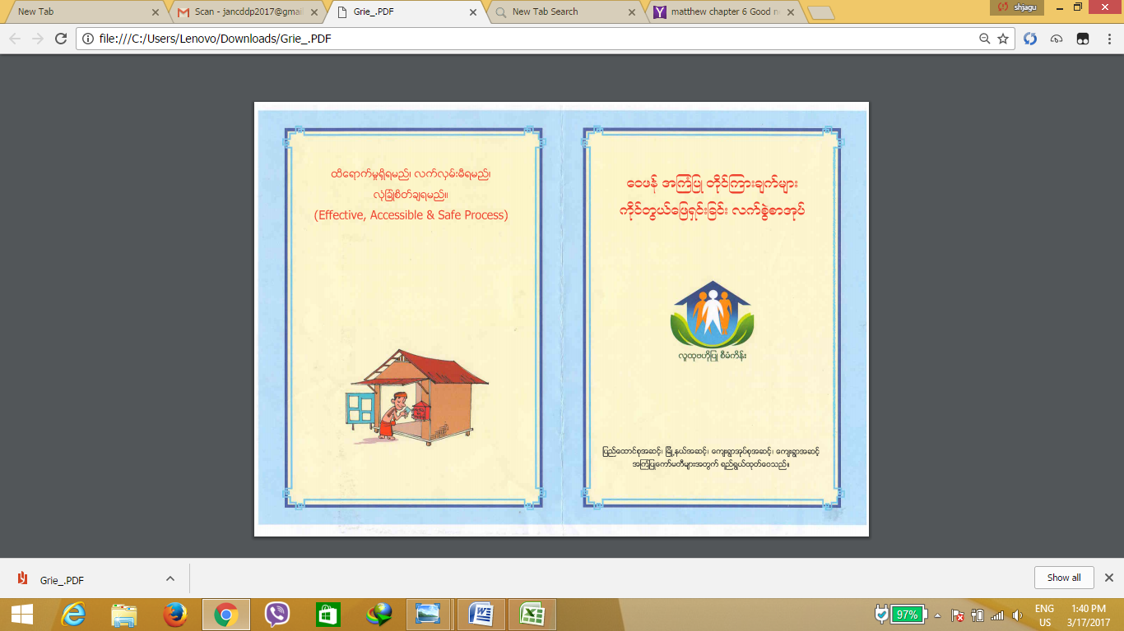
The candidate bidders can obtain a sample Manual Booklet For Focal Persons from the Department of Rural Development on simple request, but are kindly asked to come collect the sample Manual Booklet For Focal Persons after having made an appointment with the Procurement Officer in charge of this ITQ.

TECHNICAL SPECIFICATIONS AND DRAWINGS
Ref No. | Specification |  | Statement of Compliance
G 81 | All the specifications listed hereunder are minimum specifications.  All the specifications listed hereunder are for goods and materials that are new, unused, of the most recent or current models, and incorporate all recent improvements in design and materials unless provided otherwise in the Contract.  The Pamphlet, Guidebooks and Envelopes included here under as example may undergo minimal changes in terms of the final text and the illustrations to be printed. The final text and the illustrations will be confirmed by DRD at the latest at the time of the signature of the Contract Agreement. |  | Quotation must state here either “Comply” of “Not Comply” against each of the individual parameters of each Specification stating the corresponding performance parameter of the equipment offered. Statements of “Comply” or “Not Comply” must be supported by evidence in the quotation and cross-referenced to that evidence.  A statement that is not supported by evidence or is subsequently found to be contradicted by the evidence presented will render the quotation under evaluation liable for rejection. A statement either in the quotation statement of compliance or the supporting evidence that is found to be false either during evaluation or the execution of the contract may be regarded as fraudulent and render the quotation or supplier liable for prosecution.
LOT 3 | Grievance Envelope
1 | Type of Paper | Standard Wallet (Open along the long edge)
2 | Paper Size | A4 size (8.27 inches x 11.69 inches) based envelope with excision on both top sides to form a glue lap and prefabricated folding lines
3 | Envelope Size | - Open/unfolded for use as letter (A4 as described in points No. 2 paper size)  - Close/folded (for use as closed envelope):  - Face- 145 x 97mm  - (Top) Flag -15mm  - Window-140mm x15mm
4 | Envelope Closures | Gummed Flag: The flag has a strip of gum which must be moistened and secured down to seal.
5 | Paper Thickness | One Mile
6 | Paper Weight | Wood free white paper 80 gram per square meter
7 | Printing Color | As per the sample picture
8 | Finish | - Delivered flat/unfolded  - Prefabricated crease lines for easy folding

Pictured example LOT 3 - Grievance Envelop
The candidate bidders can obtain a Grievance Envelop from the Department of Rural Development on simple request, but are kindly asked to come collect the sample Grievance Envelop after having made an appointment with the Procurement Officer in charge of this ITQ.
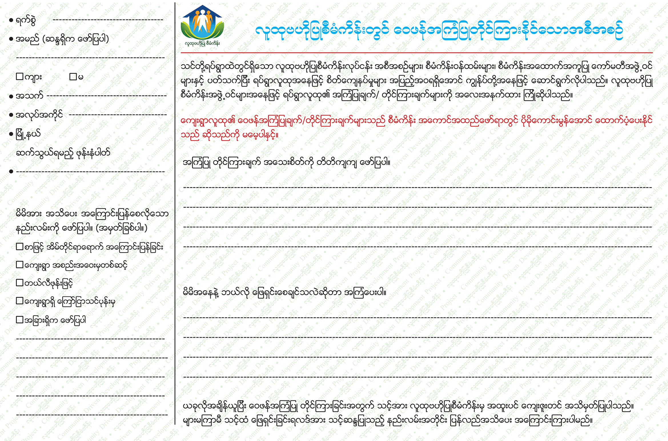

The Supplier is required to mention make / model (as applicable) of the goods to be supplied and must attach the appropriate original printed literature, brochures and performance manuals for the various items listed.

For the Supplier: | Stamp
Company/ Supplier Name:

Signature:

Authorized person name:

Designation:

SECTION 5. FORM OF BID
(Date)
To: The NCDD Project Secretariat
Department of Rural Development
Ministry of Agriculture, Livestock and Irrigation
Office N° 14, Nay Pyi Taw, Republic of the Union of Myanmar

We offer to supply in conformity with the Bidding Documents and in accordance with the Delivery Schedules specified therein, the following Goods: G-81 Printed Items for Grievance Handling for 47 Project Townships, 15 Regional Office and Union NCDDP. The total price of our Bid, including any discounts offered, is:
_________________________________________________[insert amount in words and figures].
We are not a Government owned entity or enterprise (or we are a government owned entity that is legally, commercially and managerially autonomous and not bidding for a contract to our supervising agency)
We are not suspended or debarred by the World Bank or other multilateral financial institution.
In competing for (and, if the award is made to us, in executing) the Contract, we undertake to observe the laws in force in the Republic of the Union of Myanmar, including the laws against fraud and corruption, including bribery.
This Bid and your written acceptance will constitute a binding Contract between us. We understand that you are not bound to accept the lowest or any Bid you receive.
We hereby confirm that this Bid will remain valid for 60 days after then Deadline for Submission of Bids.
We note and accept without reservation the Government’s and the World Bank’s(when other than the Government) right to audit and inspect any and all records relating both to the preparation of our Bid, and if our Bid is successful, the execution of the resulting contract according to the Attachment 1 – ‘World Bank Policy – Corruption and Fraudulent Practices’.
Authorized Signature: ______________________
Name and Title of Signatory ______________________
Name of Bidder: _________________________________________________________________
Address: _______________________________________________________________________
Phone Number: __________________________________________________________________
Fax Number, if any: ______________________________________________________________
Stamp

SECTION 6. FORM OF CONTRACT AGREEMENT

AGREEMENT
This Agreement, made the _day of 20._,by and between

Department of Rural Development
Ministry of Agriculture, Livestock and Irrigation
Office N° 14, Nay Pyi Taw, Republic of the Union of Myanmar

Hereinafter called “the Purchaser” and

_______________________________________________________________________________________
_______________________________________________________________________________________
[insert name and address of Supplier](hereinafter called “the Supplier”).

Whereas the Purchaser invited bids for certain Goods viz., [insert brief description of Goods]and has accepted a Bid by the Supplier for the supply of those Goods in the sum of [insert Contract Price in words and figures] (hereinafter called “the Contract Price”).
Now this Agreement witnessed as follows:
- In this Agreement, words and expressions shall have the same meanings as are respectively assigned to them in the Conditions of Contract hereafter referred to, and they shall be deemed to form and be read and construed as part of this Agreement.

- The following documents shall constitute the Contract between the Purchaser and the Supplier, and each shall be read and construed as an integral part of the Contract:
  - The Form of Contract,
  - The Conditions of Contract,
  - The Special Conditions of Contract
  - The Technical Specifications
  - The Form of Bid submitted by the Supplier,
  - The Price and Delivery Schedule,
  - The Purchaser’s Notification of Award

- This Contract shall prevail over all other Contract documents. In the event of any discrepancy or inconsistency within the Contract documents, then the documents shall prevail in the order listed above.

- In consideration of the payments to be made by the Purchaser to the Supplier as hereinafter mentioned, the Contractor hereby covenants with the Purchaser to execute and complete the Contract in conformity in all respects with the provisions of the Contract.

- The Purchaser hereby covenants to pay the Supplier in consideration of the execution and completion of the Contract the Contract Price or such other sum as may become payable under the provisions of the Contract at the times and in the manner prescribed by the Contract.

In Witness whereof the parties thereto have caused this Agreement to be executed the days and year first before written

The Common Seal of

Was here on to affixed in the presence of:

Signed, Sealed, and Delivered by the said

In the presence of:

Binding Signature of Purchaser:

Binding Signature of Supplier:_

SECTION 7. BID AND PERFORMANCE SECURING DECLARATION

[The Bidder shall fill in this form in accordance with the instructions indicated in brackets and submit it with the Bid.]
Date:[insert date]
Name of contract:[insert name] Contract Identification No: [insert number] Invitation to Quote N°:[insert number]

To: Department of Rural Development
Ministry of Agriculture, Livestock and Irrigation
Office N° 14, Nay Pyi Taw, Republic of the Union of Myanmar

We, the undersigned, declare that:
- We understand that, according to your conditions, bids must be supported by a bid and performance securing declaration.
- We accept that we shall be suspended from being eligible for bidding in any contract with the Purchaser and the Government of …… for the period of time of two years starting on the date of the Purchaser’s execution of this Declaration or pay 2% of the contract price as a penalty, if we are in breach of our obligation(s) under the bid conditions and contract conditions, because we:
  - Have withdrawn our Bid during the period of bid validity specified by us in the Bid Submission Sheet; or

  - Do not accept the correction of errors in accordance with the Instructions to Bidders of the Bidding Documents, or
  - Having been notified of the acceptance of our Bid by the Purchaser during the period of bid validity, fail or refuse to execute the Contract Form, if required, or
  - Committed a fundamental breach of contract leading to the Purchaser’s termination of the contract for reasons of our default.
- We understand this bid securing declaration shall expire if we are not the successful bidder, upon the earlier of (i) our receipt of a copy of your notification that we were unsuccessful; or (ii) 30 (thirty) days after the expiration of our bid, or in the event that our bid is successful and we are awarded a contract we understand that this bid and performance securing declaration will expire upon successful completion of the warranty period specified in paragraph 7 of the Conditions of Contract.

- We understand that if we are a JV, the Bid and Performance Securing Declaration must be in the name of the JV that submits the bid. If the JV has not been legally constituted at the time of bidding, the Bid Securing Declaration shall be in the names of all future partners as named in the letter of intent.
Signed [insert signature(s) of authorized representative] In the Capacity of [insert title]
Name [insert printed or typed name]
Duly authorized to sign the bid for and on behalf of [insert authorizing entity]
Dated on [insert day]day of[insert month], [insert year]

Stamp

In this context, any action to influence the procurement process or contract execution for undue advantage is improper.
For the purpose of this sub-paragraph, “another party” refers to a public official acting in relation to the procurement process or contract execution. In this context, “public official” includes World Bank staff and employees of other organizations taking or reviewing procurement decisions.
For the purpose of this sub-paragraph, “party” refers to a public official; the terms “benefit” and “obligation” relate to the procurement process or contract execution; and the “act or omission” is intended to influence the procurement process or contract execution.
For the purpose of this sub-paragraph, “parties” refers to participants in the procurement process (including public officials) attempting either themselves, or through another person or entity not participating in the procurement or selection process, to simulate competition or to establish bid prices at artificial, non-competitive levels, or are privy to each other’s bid prices or other conditions.
For the purpose of this sub-paragraph, “party” refers to a participant in the procurement process or contract execution.
A firm or individual may be declared ineligible to be awarded a Bank financed contract upon: (i) completion of the Bank’s sanctions proceedings as per its sanctions procedures, including, inter alia, cross-debarment as agreed with other International Financial Institutions, including Multilateral Development Banks, and through the application the World Bank Group corporate administrative procurement sanctions procedures for fraud and corruption; and (ii) as a result of temporary suspension or early temporary suspension in connection with an ongoing sanctions proceeding. See footnote 14 and paragraph 8 of Appendix 1 of these Guidelines.
A nominated sub-contractor, consultant, manufacturer or supplier, or service provider (different names are used depending on the particular bidding document) is one which has either been: (i) included by the bidder in its pre-qualification application or bid because it brings specific and critical experience and know-how that allow the bidder to meet the qualification requirements for the particular bid; or (ii) appointed by the Borrower.

